SIMATS ENGINEERING

ASSESSMENT TOOL 2

COURSE CODE: CSA14 COURSE NAME: COMPILER DESIGN

COURSE OUTCOME COVERED

CO2: Construct top-down and bottom up parsers using CFG for parsing conflicts and error recovery for efficient syntax tree generation (BL3)

Assessment Tool Weightage: 20%

Duration :60 Mins On Class
QUESTIONS: 25 Total Marks:50

Annexure A

SHORT ANSWER TEST

Code of Conduct:

I Tejaswi Reddy K (192371036) certify that this submission is my original work and that I have adhered to the guidelines specified for this assessment.
I understand that any violation of academic integrity rules will result in disciplinary action.

Signature of the student:



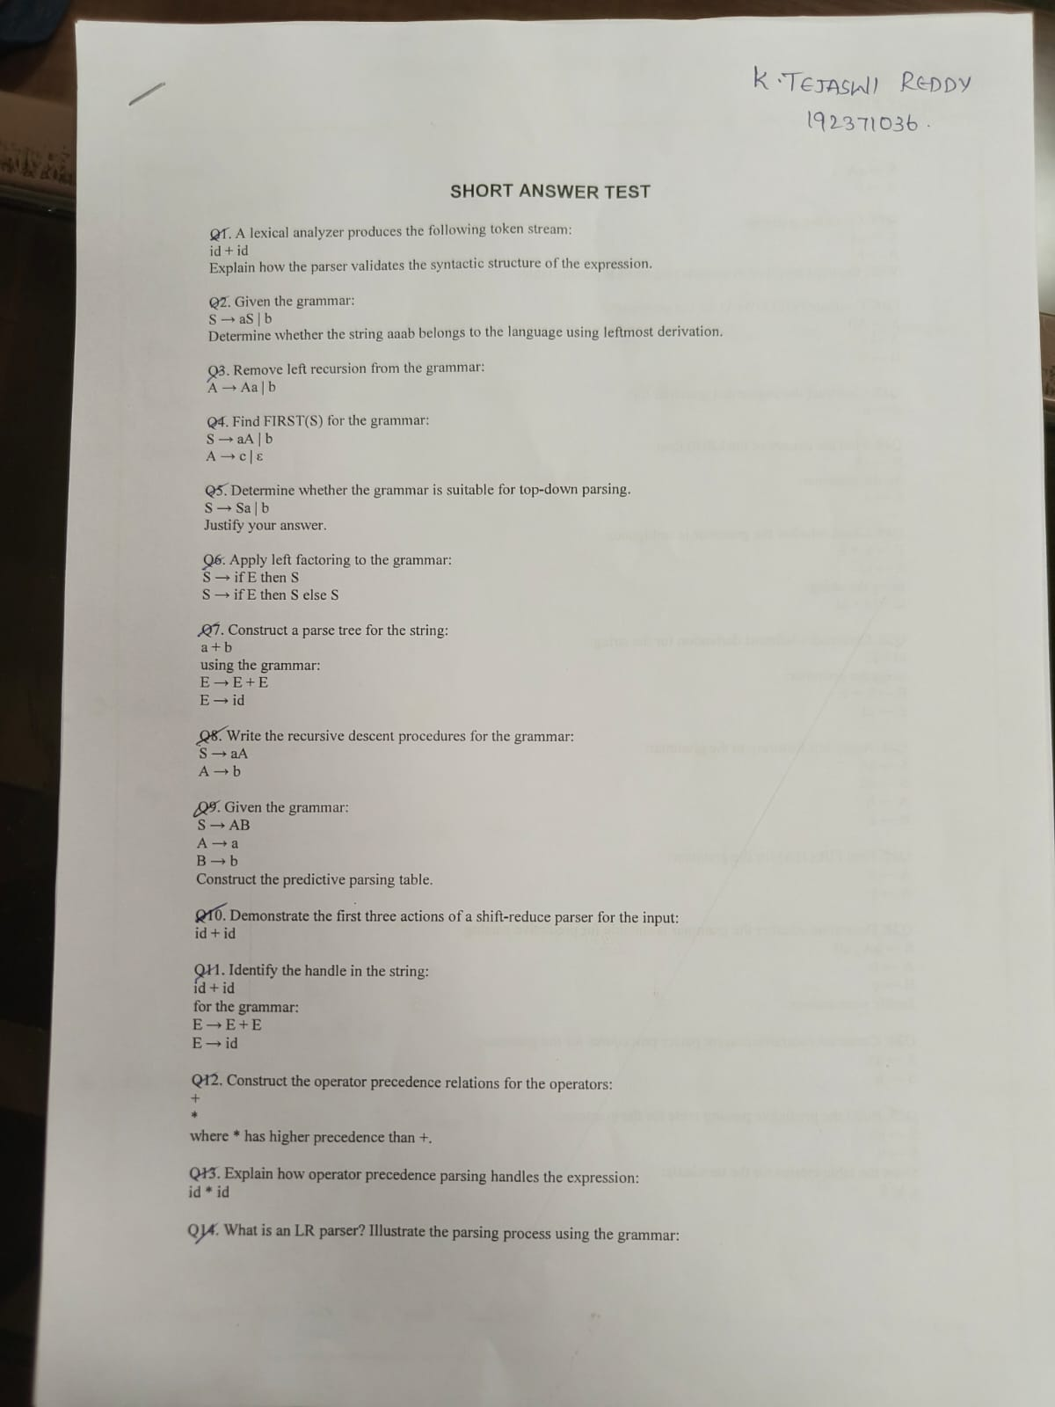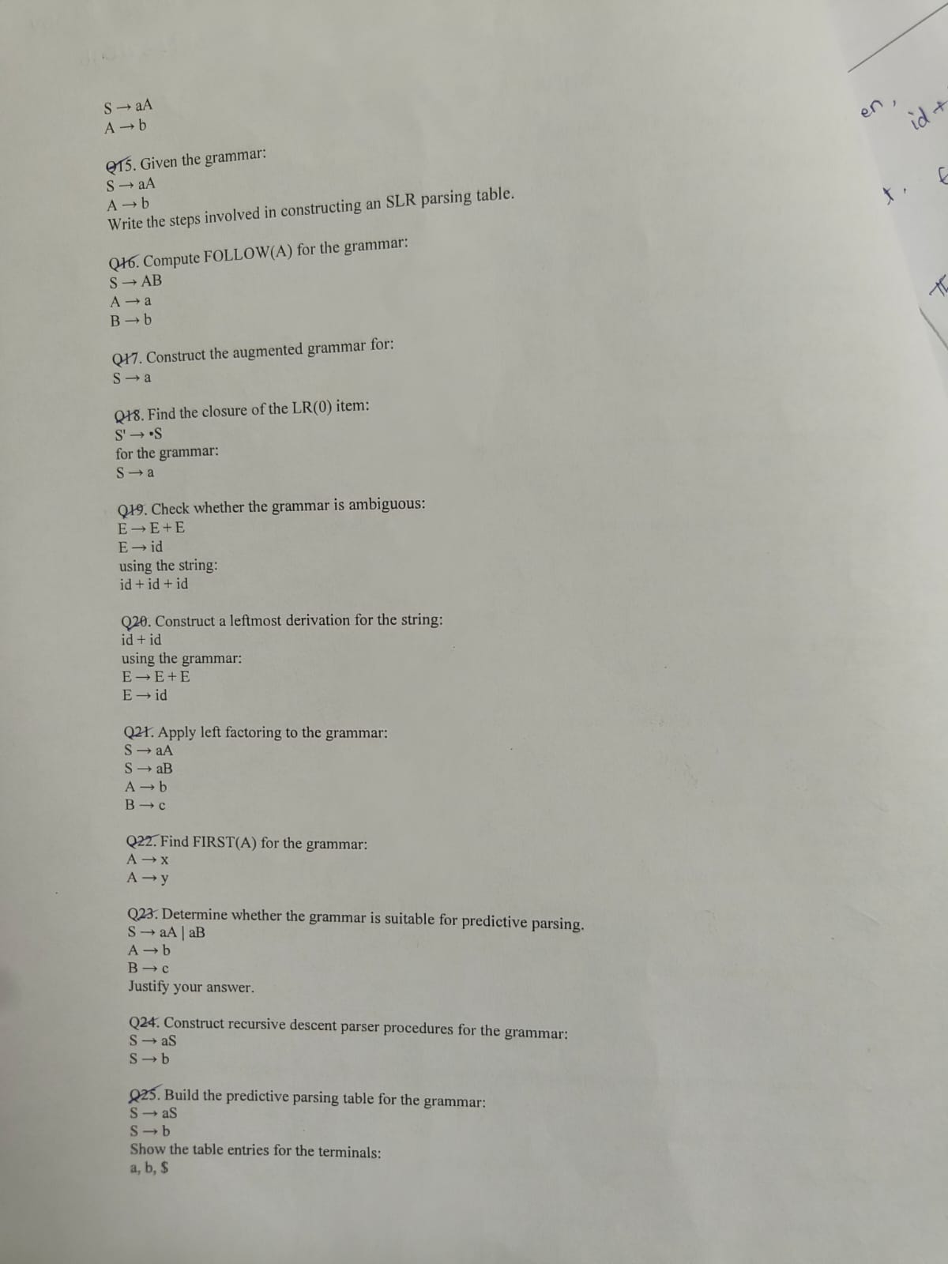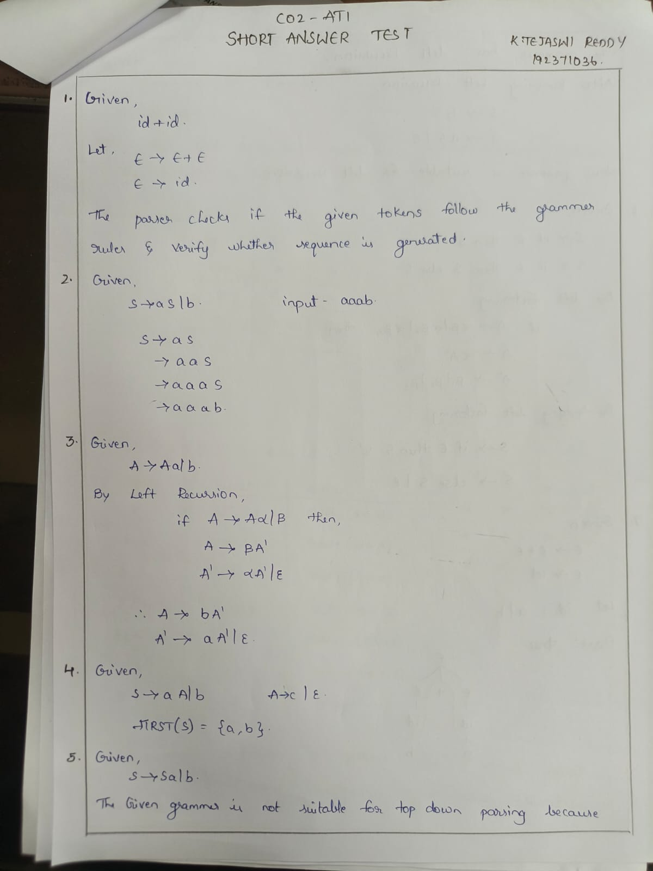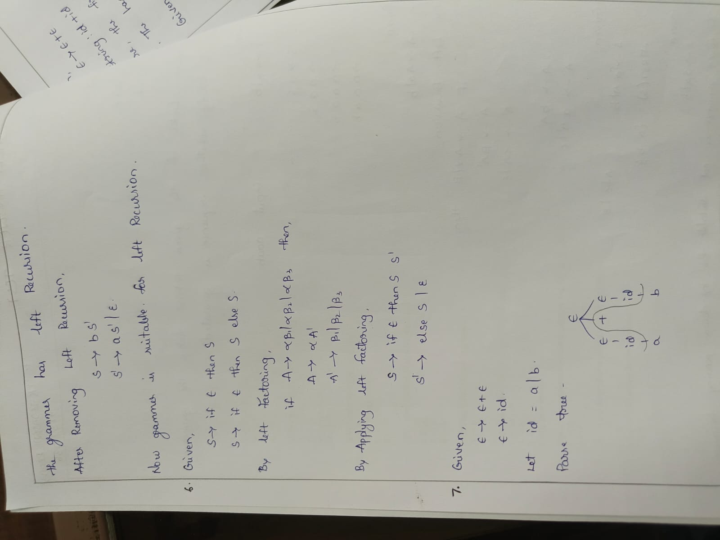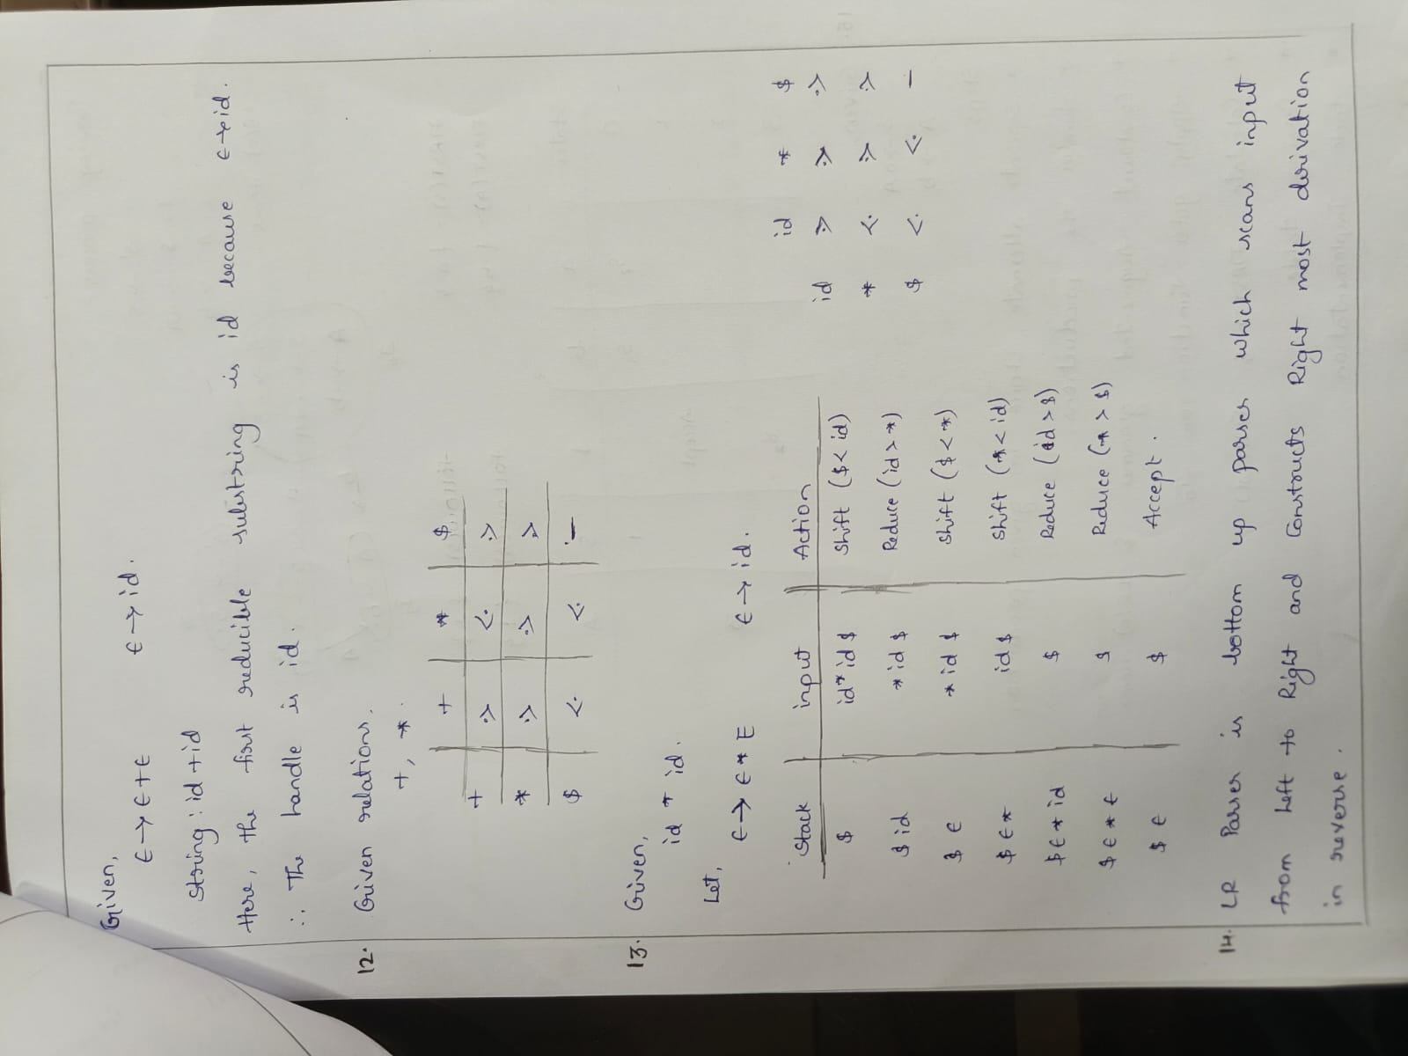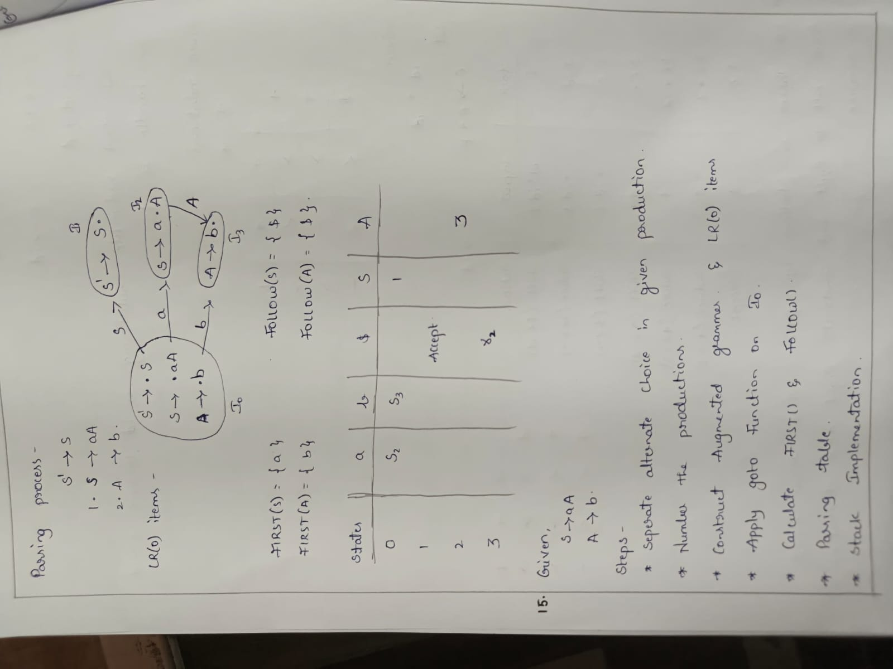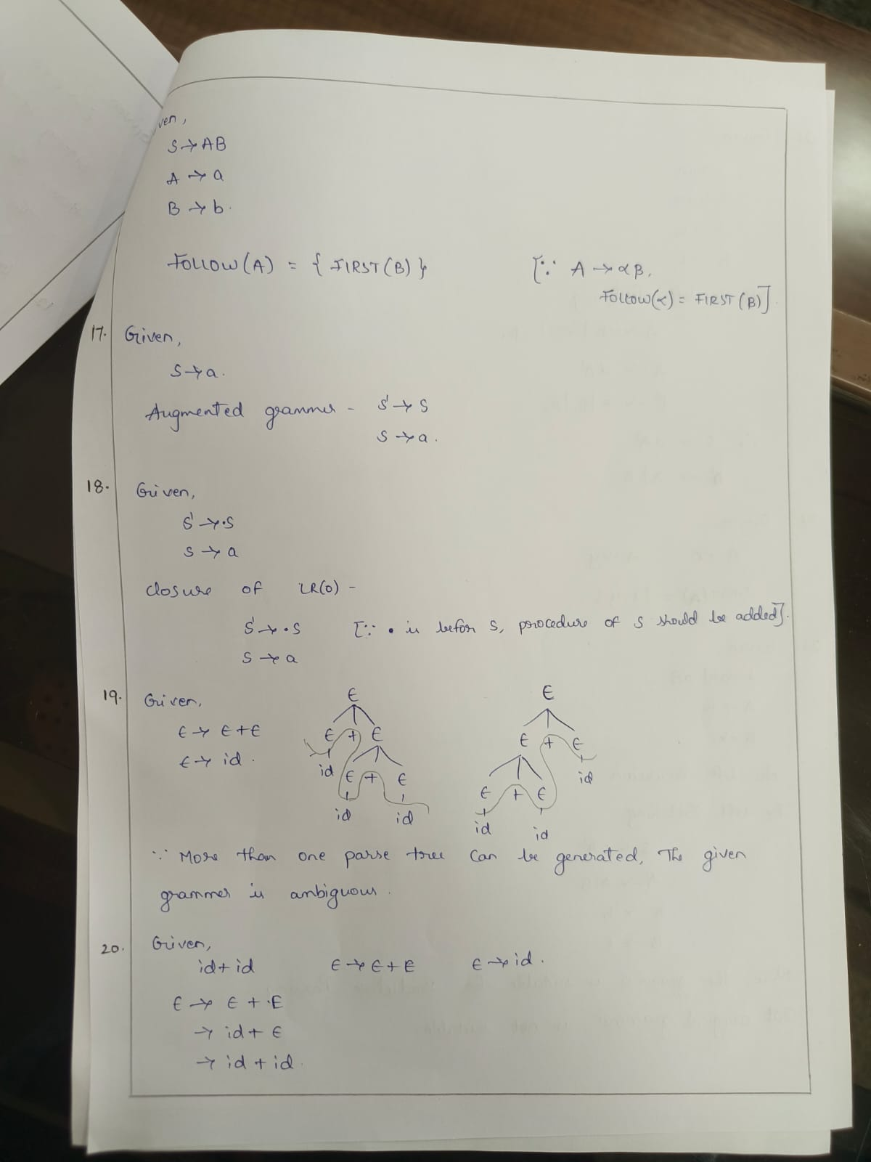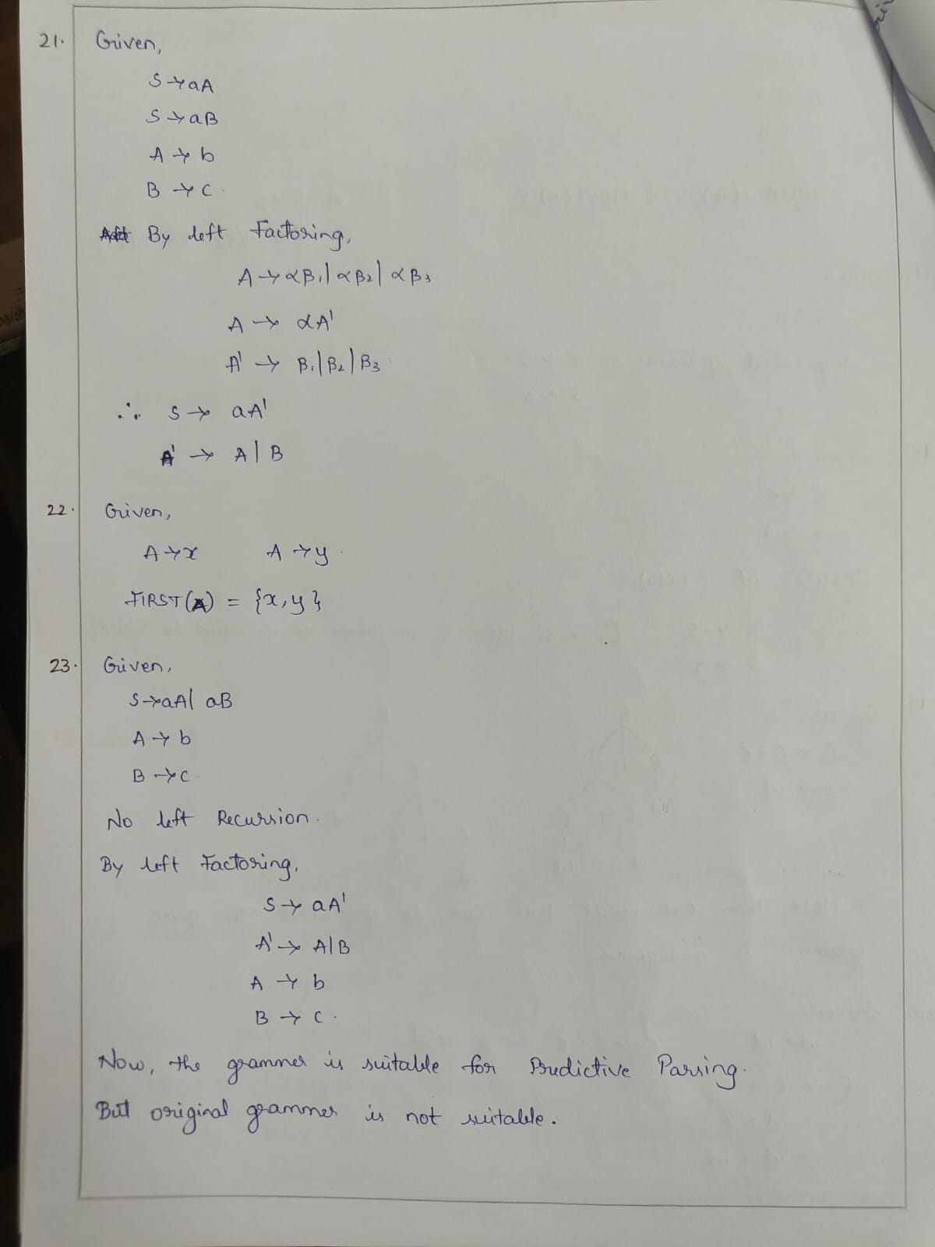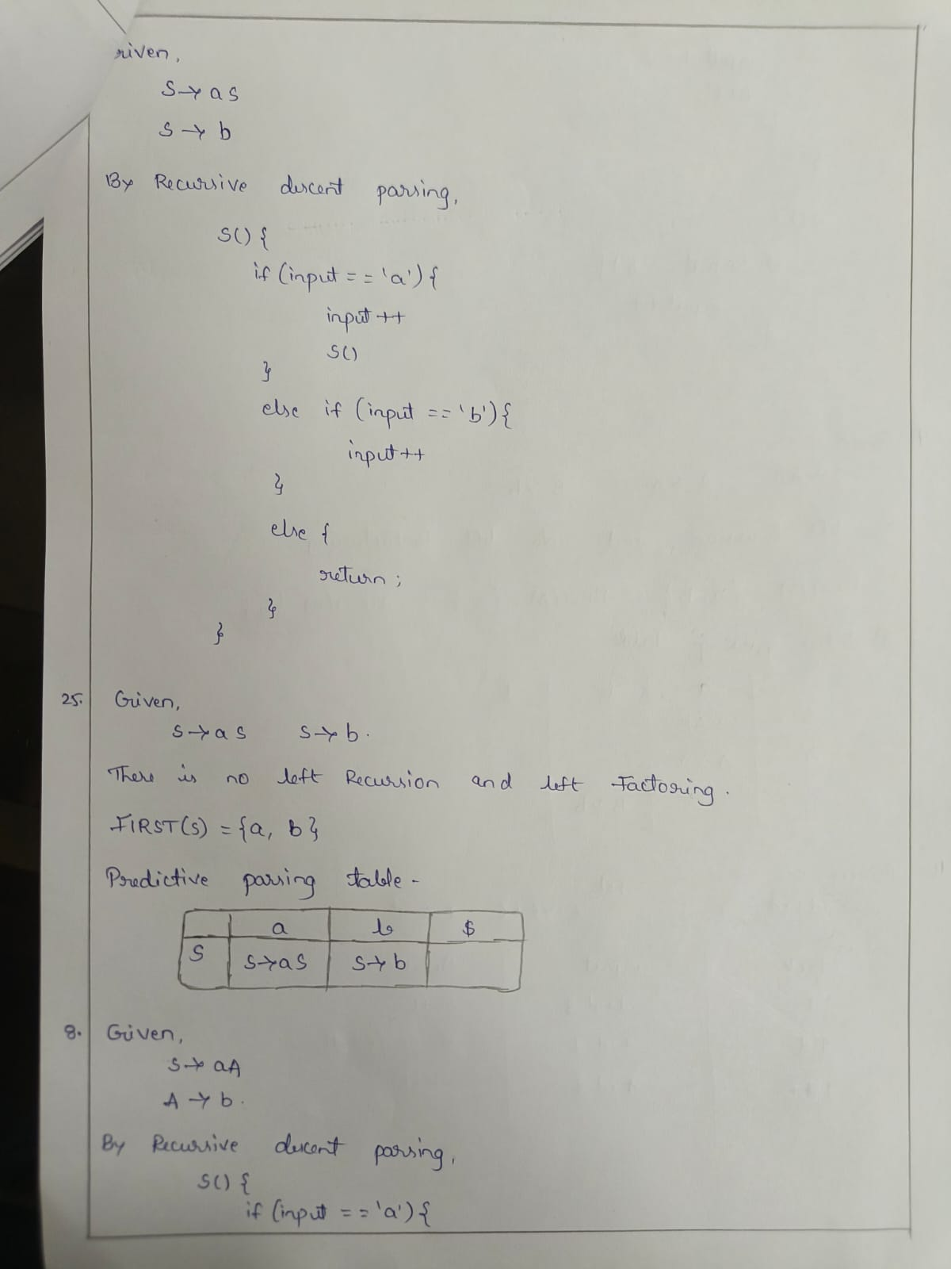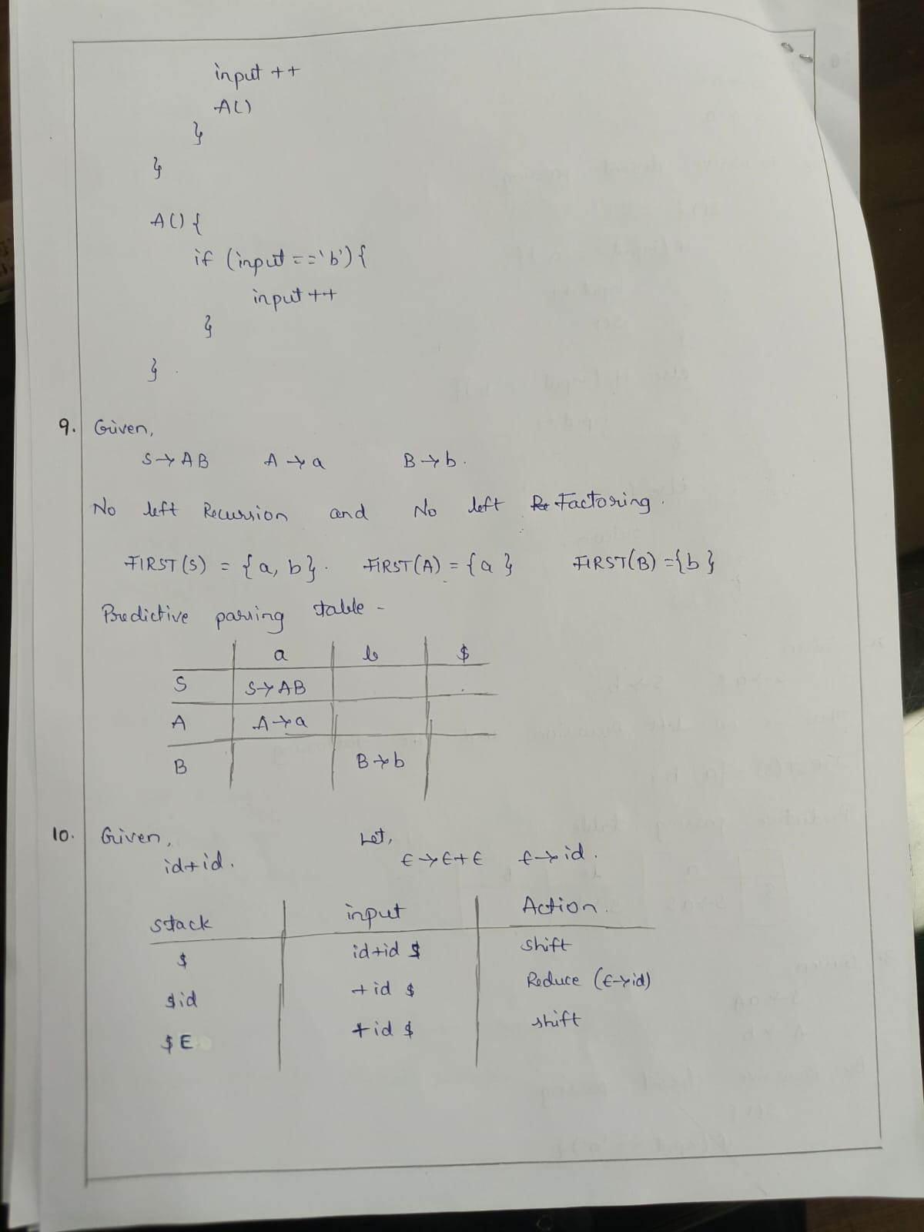

RUBRICS FOR CALCULATION

Criteria | Weightage | Level 4 – Exemplary | Level 3 – Proficient | Level 2 – Developing | Level 1 – Beginning
Understanding of Concepts | 25% | Demonstrates thorough, accurate understanding  of concepts | Good understanding with minor gaps | Basic understanding with some misconceptions | Poor understandi ng; major misconcepti  ons
Explanation | 25% | Detailed, well-explained answers with relevant  examples | Clear explanation with adequate details | Limited explanation; lacks depth | Poor or unclear explanation
Application | 20% | Effectively applies concepts with strong  analytical ability | Applies concepts with minor errors | Limited application with weak analysis | No application or incorrect analysis
Organization | 15% | Well-structured answers with logical flow and  coherence | Organized with minor issues in flow | Basic structure, lacks clarity | Poor organization  , incoherent answers
Accuracy | 10% | Completely accurate and covers all  required points | Mostly accurate with minor omissions | Partially correct with missing points | Incorrect answers with major  gaps
Clarity | 5% | Clear, neat, professional presentation | Understandable with minor issues | Limited clarity, readability issues | Poorly written, difficult to understand

